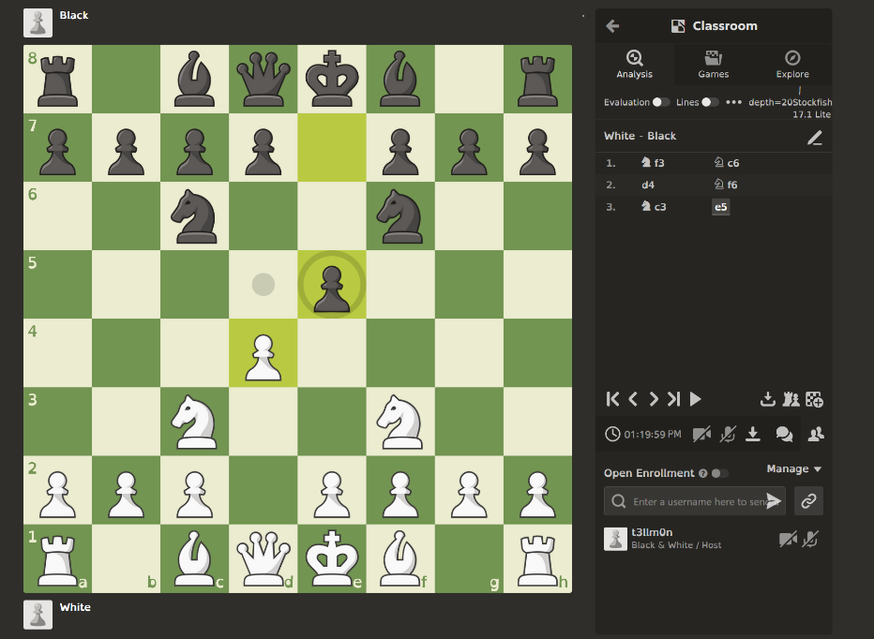
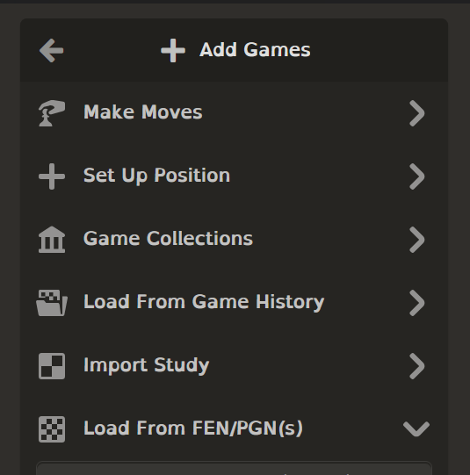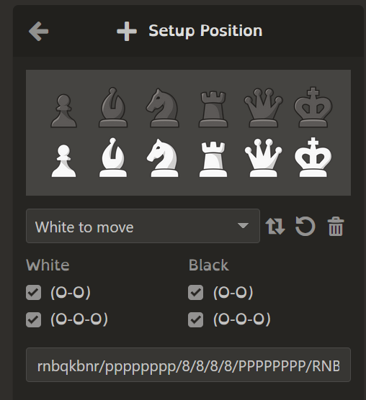
This button brings up a menu to be able to load a board for FEN or PGN notation which is useful to store board states in and easy to edit. FEN show the board it is in now while PEN shows the way it took to get there. So, all the moves. FEN is probably easier to implement. Both standards are popular so in this app it’s easy to import board from other examples using this format.
The button on the side makes it easy for the user to easily access each side and for this to set up the position in this board while on the application. Pressing this button spawns a windows panel that can be used to set up and put pieces on the board. This is convenient so the teacher I does not need to leave the app to set up board positions.
This download button makes it easy to export the board for later and easily import it again for ease of use and make life easier for the teacher, so they don’t have to re make the board each time.
You can quite easily see where the white pawn can move in this position. This is useful to the student as you can see where the pawn can move if you are known to the game.
The board is quite easy to see. With pieces visible. From the back and the board is the main part of the program which is easy to see. Which would be good for the back of the board.
This is the menu that pops up when you hit Setup Position. This is a little button menu for you to easily set up a board which is quite convenient for the user as to make a board to learn from all they need is to press this button and put the pieces in their places on the board.

